WOMEN IN FILM & VIDEO
WIFV.ORG

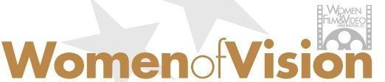

27th AWARDS CELEBRATION
April 23, 2026 @ 6:00 PM
National Museum of Women in the Arts
1250 New York Avenue NW
Washington, DC 20005

SPONSORSHIP PROPOSAL

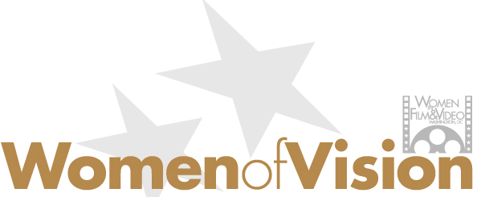

Join us on April 23, 2026, for a very special evening honoring trailblazing women of vision. Past recipients have included a broad range of women working in broadcast news, feature films, documentaries, and advocacy work in positions in front of and behind the camera. All have enriched human experience through their storytelling. Their creative and technical achievements in media and the caliber of their work on- and off-screen firmly establish them as WIFV role models and women to be recognized.

The 2026 Women of Vision honorees include Kate Beyda, Executive Vice President of Physical Production at New Line Cinema, and two others who will be confirmed by February 28, 2026.

The 2025 honorees were Cinematographer/Director Rachel Morrison, Director/Producer Robin Noonan-Price, and Writer/Director/ Showrunner Felicia Pride. The program was moderated by Linda Holmes, NPR Pop Culture Correspondent.

A full list of WIFV Women of Vision honorees is available here.

Your sponsorship will enable Women in Film & Video to continue providing educational programs, financial support, and networking opportunities to screen-based media makers in the Mid-Atlantic Region, as well as recognize and celebrate excellence in the industry.

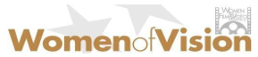

2026 WOMEN OF VISION SPONSORSHIP OPPORTUNITIES
A unique opportunity to show your leadership and support of Mid-Atlantic media makers

$10,000 Platinum Sponsor (Exclusive)
      - Women of Vision presented by {Company Name}
      - 10 Tickets to Awards Ceremony with reserved seating
      - Prominent branding on step-and-repeat
      - Recognition in all pre- and post-event publicity
      - On-stage recognition of sponsorship and photo with honorees
      - Educational sponsor for 2026 professional development programs
      - VIP Tour of the National Museum of Women in the Arts
$5,000 Gold Sponsorship
      - 8 Tickets to Awards Ceremony with reserved seating
      - Recognition in all pre- and post-event publicity
      - On-stage recognition of sponsorship
      - Networking sponsor for 2026
      - VIP Tour of the National Museum of Women in the Arts

$2,500 Silver Sponsorship
      - 4 Tickets to Awards Ceremony with reserved seating
      - Recognition in all pre- and post-event publicity
      - On-stage recognition of sponsorship
      - Includes sponsorship of two WIFV networking events
      - VIP Tour of the National Museum of Women in the Arts

$1,500 Bronze Sponsorship
      - 2 Tickets to Awards Ceremony with reserved seating
      - Recognition in all pre- and post-event publicity
      - Includes sponsorship of one WIFV networking event
      - VIP Tour of the National Museum of Women in the Arts
Deadline for Sponsorships is March 31, 2026
Questions: Contact Melissa Houghton | 202.429.9438 | director@wifv.org

SPONSORSHIP RESPONSE FORM
DEADLINE: March 31, 2026

Yes! We would like to support Mid-Atlantic media makers by being a sponsor of Women in Film & Video’s 2026 Women of Vision Awards.

LEVEL OF SPONSORSHIP (PLEASE CHECK ONE):
- Platinum Sponsor (Exclusive) $10,000
- Gold Sponsor $5,000
- Silver Sponsor $2,500
- Bronze Sponsor $1,500
- We cannot sponsor this year but would like to make a tax-deductible donation. Donation Amount: $_____________

We are interested in placing an honoree tribute in the printed program.
- Full page (5” x 7.75”) $1,000
- Half page (5” x 4”) $500

****************************************************************************
COMPANY NAME: ______________________________________________________

CONTACT PERSON: ______________________________________________________

ADDRESS: __________________________________________________________

CITY: ____________________ STATE: ____________ ZIP: __________

PHONE: _____________________________________

EMAIL: _____________________________________

WEBSITE: _____________________________________

Sponsorship payments and donations can be made by credit card or check. Mail checks to:
Women in Film & Video (WIFV)
921 Pennsylvania Avenue SE, Washington, DC 20003
Make payment by credit card here
Questions: Contact Melissa Houghton | 202.429.9438 | director@wifv.org

Expanded Sponsorship & Partnership Opportunities
In addition to financial sponsorships, Women in Film & Video welcomes in-kind partnerships and experiential contributions that elevate the 2026 Women of Vision Awards and directly support women working in screen-based media. These opportunities allow brands, creators, and community partners to engage with our audience in meaningful, high-visibility ways while supporting a mission-driven celebration of trailblazing women.
We Are Currently Welcoming
Silent Auction Contributions
Cool, distinctive, and valuable items that will excite our guests and support our fundraising efforts, including but not limited to:
- Travel experiences, retreats, or hotel stays
- Wellness, beauty, or lifestyle packages
- Art, collectibles, or exclusive experiences
- Creative services or industry-adjacent offerings
Please fill out this form for your Silent Auction Donation
Attendee Gift Bag Contributions
Thoughtful, premium items curated for our honorees and guests, such as:
- Beauty, wellness, or self-care products
- Fashion, accessories, or luxe lifestyle items
- Books, media, or creative tools by women creators
- Branded items aligned with empowerment, creativity, and style
Email Melissa Houghton at director@wifv.org to discuss this opportunity.
In-kind donors will be recognized appropriately based on the value and nature of their contribution and may receive visibility through event signage, digital promotions, social media recognition, and inclusion in event materials.
Why Partner with Women in Film & Video?
Your involvement helps Women in Film & Video support the Mid-Atlantic media community in the following ways:
- Providing high-quality Professional Development Programming
- Direct support for two documentary projects per year through the Seed Fund for Documentary Filmmakers
- Networking opportunities for screen-based media makers in the Mid-Atlantic region
If you have any questions, please contact Melissa Houghton at 202-429-9438 or director@wifv.org Thank you!

